1. Introduction

1.1 Purpose

The sole purpose of this document lies in specifying the software requirement specifications of our project “The ClassMate”,v1.0.

This document covers the basic functionalities of this project and provides a short description about those functionalities .It speaks about the various classes of users involved and their corresponding use cases.

1.2 Document Conventions

There are no such document conventions followed in this document.

1.3 Intended Audience and Reading Suggestions

This document is specifically meant for those who are just beginning to make use of our product .This document is written in such a way that it is easier to all class of people even those who are completely new to online.

This document also covers certain technical aspects although not that deep but still the basic idea of all the functionalities are covered so that developers who wish to contribute anything in addition to it feel easier.

1.4 Product Scope

The product under discussion is “The ClassMate”.This is an online platform where mentors can monitor their students and students can see tests , webinars scheduled by their mentors and admin will be able to view the progress of both mentors and students

This platform attempts to make the process of interaction between a student and faculty online so that the student’s education can be done at wherever he/she is.

1.5 References

This references used for this project are as follows :

1. <https://getbootstrap.com/> -- CSS frameworks
2. <https://colorlib.com/etc/regform/colorlib-regform-2/> -- For Looks and Design Inspirations
3. <https://fontawesome.com/> -- Fonts
4. <https://www.flaticon.com/> - Fonts
5. <http://www.passportjs.org/docs/> -- Authentication
6. <https://classroom.google.com/u/1/c/MzczMjQzNTI2NjI0/m/Mzc2NzAzMjk3Mjkx/details> -- SRS Template

**Overall Description:**

**Product perspective:**

This application serves to be an attractive replacement for the online classroom for students.

This software attempts to provide the user with a clear-cut comparison between the students,admins and the mentors.

This software allows students to give feedback,attend the test and admin to assign the mentor to the students and mentor to schedule the test and webinar.

This software allows admins to view the overall performance of the students and also the mentors.

Product functions:

In student perspective,

The students can attend the test and also the webinar that are provided by the mentor and give feedback about the session.

In mentor perspective,

The mentor can schedule the test and webinar and also view the attendance of the students.

The admins can view the both student and mentor performance.

**User classes and characteristics:**

**1.students:**

Frequency of usage---more

Product functions used---The students can attend the scheduled test and webinars that are assigned by the particular mentors.

The users of this class mostly make use of the information providing functionality of the software.

**2.mentors:**

Frequency of usage—average

Product functions used—the mentor can schedule test and also view the attendance of the students.

The user of this class provide the test to students according to the instructions provided by the admins.

**3.administrator:**

Frequency of usage—daily

Product functions used—the functionality to view the overall records of the mentors and the performance of the students.

The user of this class use this software to assign the mentors to the students and also view the feedback that are provided by the students.

**Operating Environment :**

This software should work peaceful with the environment specified as follows :

1.Operating System—Windows 8,8.1,10

2.Execution Platform---chrome,Mozilla firefox with tomcat server installed.

Design and Implementation Constraints

In general this software requires a Windows 8,8.1,10 Operating System and also a chrome/firefox with tomcat server installed.

This software works fine with chrome/firefox in localhost server.

The maintenance and the response speed of the software will purely depend on the user’s system configuration.

User documentation:

Manual:

In students view,

1.the student is expected to login to the online classmate.

2.then the students expected to attend the test and webinars that are scheduled by the mentors and also give the feedback in the feedback section.

In mentor view,

1.the mentor should login the mentor section in online classmate.

2.then the mentor can assign the test and webinars to the students and also view the attendance of the particular students in the attendance section.

In admin view,

1.the admin should login the admin section in online classmate.

2.then the admin can view the feedback that are provided by the students in feedback section and also assign the mentors to students in assign section.

Assumptions and dependencies:

This software assumes that the executing operating system is either Windows 8,8.1 or 10

The users are assumed to have a basic knowledge on operating the computer and know how to run the localhost server.

They are assumed to know how to input and view output in a online platform.

**MENTOR’S SYSTEM FEATURE**

**4.1** **SCHEDULE TESTS:**

**4.1.1 DESCRIPTION AND PRIORITY:**

This system feature is meant for the mentors to schedule different tests on various slots for the students.

This system feature is of high priority as it deals with the scheduling of the tests.It is very much important to indicate the students with their appropriate test schedules as per the mentor’s scheduling.

**4.1.2 STIMULUS/RESPONSES:**

**1.**Initially the mentor is prompted to select the date,time and title for the test.

**2.**After the mentor updates the above mentioned details,the test schedules is displayed to the students.

**4.1.3 FUNCTIONAL REQUIREMENTS:**

**REQ1:**The objective of this feature to facilitate the mentors to schedule tests for the students.

**REQ2:** This system feature strives to achieve its objective via an user friendly interaction with the user.

**4.2 SCHEDULE WEBINARS:**

**4.2.1 DESCRIPTION ANN PRIORITY:**

This system feature is meant for the mentors to schedule different webinars on various slots for the students.

This system feature is of high priority as it is very much important to indicate the students with their webinars on a right basis.

**4.2.2 STIMULUS/RESPONSES:**

**1.**Initially the mentor is prompted to select the date,time ,title and speaker of the webinar.

**2.**After the mentor updates the above mentioned details,the webinar schedule is displayed to the students.

**4.2.3 FUNCTIONAL REQUIREMENTS:**

**REQ1:**The objective of this feature to facilitate the mentors to schedule webinars for the students.

**REQ2:** This system feature strives to achieve its objective via an user friendly interaction with the user.

**4.3 ATTENDANCE MARKING:**

**4.3.1 DESCRIPTION AND PRIORITY:**

This system feature is meant for the mentors to mark and maintain the attendance of each and every individual student on hourly basis.

This system feature is of high priority as it is very crucial to maintain the precise attendance of each and every individual student.

**4.3.2 STIMULUS/RESPONSES:**

**1.**Initially the mentor is prompted to mark the attendance of all the students as per the schedule.

**2.**After the mentor updates the above mentioned details,the consolidated attendance is then displayed to the mentors.

**4.3.3 FUNCTIONAL REQUIREMENTS:**

**REQ1:**The objective of this feature to facilitate the mentors to have a consolidated attendance of the students.

**REQ2:** This system feature strives to achieve its objective via an user friendly interaction with the user.

**4.4 GRADING STUDENTS:**

**4.4.1 DESCRIPTION AND PRIORITY:**

This system feature is meant for the mentors to grade and maintain the grade of each and every individual student on hourly basis.

This system feature is of high priority as it is very crucial to maintain the appropriate grade of each and every individual student for every single task.

**4.4.2 STIMULUS/RESPONSES:**

**1.**Initially the mentor is prompted to mark the grade of all the students as per the allotted assignments.

**2.**After the mentor updates the above mentioned details,the consolidated mark is then displayed to the mentors.

**4.4.3 FUNCTIONAL REQUIREMENTS:**

**REQ1:**The objective of this feature to facilitate the mentors to have a consolidated grades of the students.

**REQ2:** This system feature strives to achieve its objective via an user friendly interaction with the user.

**4.5 VIEWING OF ATTENDANCE:**

**4.5.1 DESCRIPTION AND PRIORITY:**

This system feature is meant for the mentors to view their overall attendance of the students whenever necessary.

This system feature is of high priority as it crucial for the mentors to view students attendance whwnever required.

**4.5.2 STIMULUS/RESPONSES:**

**1.**Initially the mentor is prompted to select the section in the portal.

**2.**After the mentor selects the attendance section,the overall attendance of the particular student is displayed

**4.5.3 FUNCTIONAL REQUIREMENTS:**

**REQ1:**The objective of this feature to facilitate the mentors to have a look at their attendance whenever required.

**REQ2:** This system feature strives to achieve its objective via an user friendly interaction with the user.

**STUDENTS’S SYSTEM FEATURE:**

**4.6 VIEWING OF TESTS AND WEBINARS:**

**4.6.1 DESCRIPTION AND PRIORITY:**

This system feature is meant for the students to view their scheduled webinars and tests.

This system feature is of high priority as it crucial for the students to view their test and webinar schedules precisely.

**4.6.2 STIMULUS/RESPONSES:**

**1.**Initially the student is prompted to select the section in the portal.

**2.**After the student selects the test or webinar section,the test and the webinar shedules are displayed respectively.

**4.6.3 FUNCTIONAL REQUIREMENTS:**

**REQ1:**The objective of this feature to facilitate thestudents to have a look at their scheduled webinars and tests.

**REQ2:** This system feature strives to achieve its objective via an user friendly interaction with the user.

**4.7 FEEDBACK:**

**4.7.1 DESCRIPTION AND PRIORITY:**

This system feature is meant for the students to register their feedback about each and every faculty.

This system feature is of medium priority as it optional for the students to register their feedback.

**4.7.2 STIMULUS/RESPONSES:**

**1.**Initially the student is prompted to select the section in the portal.

**2.**After the student selects the feedback section,the feedback form is displayed for filling.

**4.7.3 FUNCTIONAL REQUIREMENTS:**

**REQ1:**The objective of this feature to facilitate the students to register at their personal opinions about the classes.

**REQ2:** This system feature strives to achieve its objective via an user friendly interaction with the user.

**4.8 VIEWING OF PROFILE:**

**4.8.1 DESCRIPTION AND PRIORITY:**

This system feature is meant for the students to view their profile details in the portal.

This system feature is of medium priority as it optional for the students to view their feed personal details.

**4.8.2 STIMULUS/RESPONSES:**

**1.**Initially the student is prompted to select the section in the portal.

**2.**After the student selects the profile section,the details about the particular student is displayed.

**4.8.3 FUNCTIONAL REQUIREMENTS:**

**REQ1:**The objective of this feature to facilitate the students to register at their personal details in the portal.

**REQ2:** This system feature strives to achieve its objective via an user friendly interaction with the user.

**ADMIN’S SYSTEM FEATURE:**

**4.9 VIEWING OF FEEDBACK:**

**4.9.1 DESCRIPTION AND PRIORITY:**

This system feature is meant for the admin to view the feedback of the students in the portal.

This system feature is of medium priority as the admins can view the feedback of the students on their desired basis.

**4.9.2 STIMULUS/RESPONSES:**

**1.**Initially the admin is prompted to select the particular subject for which s/he is interested in viewing the feedback

**2.**After the admin selects the subject ,the feedback about the particular subject is displayed.

**4.9.3 FUNCTIONAL REQUIREMENTS:**

**REQ1:**The objective of this feature to facilitate the admins to have a look at the feedback of the students.

**REQ2:** This system feature strives to achieve its objective via an user friendly interaction with the user.

**4.10 ASSIGNING MENTORS:**

**4.10.1 DESCRIPTION AND PRIORITY:**

This system feature is meant for the admin to assign the mentors to the students in the portal.

This system feature is of high priority as it is very important for the admins to assign appropriate mentors to the students without any clash

**4.10.2 STIMULUS/RESPONSES:**

**1.**Initially the admin is prompted to select a particular mentor for a particular batch of students.

**2.**After the admin selects the mentor ,the allotted mentor for the batch is displayed.

**4.10.3 FUNCTIONAL REQUIREMENTS:**

**REQ1:**The objective of this feature to facilitate the admins to allot mentors to the students.

**REQ2:** This system feature strives to achieve its objective via an user friendly interaction with the user.

**4.11 ADDITION AND DELETION OF MEMBERS:**

**4.11.1 DESCRIPTION AND PRIORITY:**

This system feature is meant for the admin to add or remove students and mentors in the portal.

This system feature is of medium priority as the admins can add and remove the members whenever required.

**4.11.2 STIMULUS/RESPONSES:**

**1.**Initially the admin is prompted to select the particular mentor/student s/he is interested in removing or adding

**2.**After the admin selects it,the membera added or removed are displayed.

**4.11.3 FUNCTIONAL REQUIREMENTS:**

**REQ1:**The objective of this feature to facilitate the admins to add or remove members in the portal with ease.

**REQ2:** This system feature strives to achieve its objective via an user friendly interaction with the user.

**USECASE DIAGRAM**

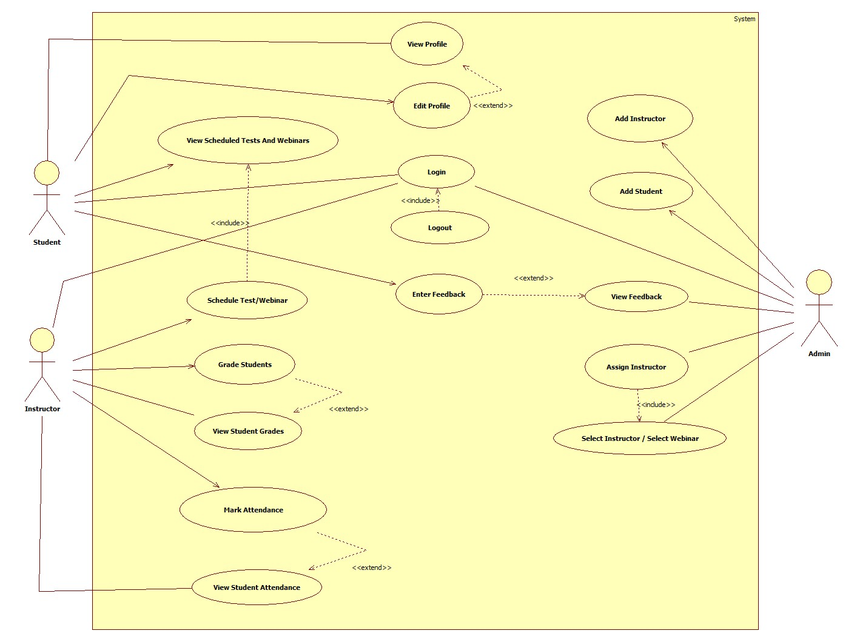

**CLASS DIAGRAM:**

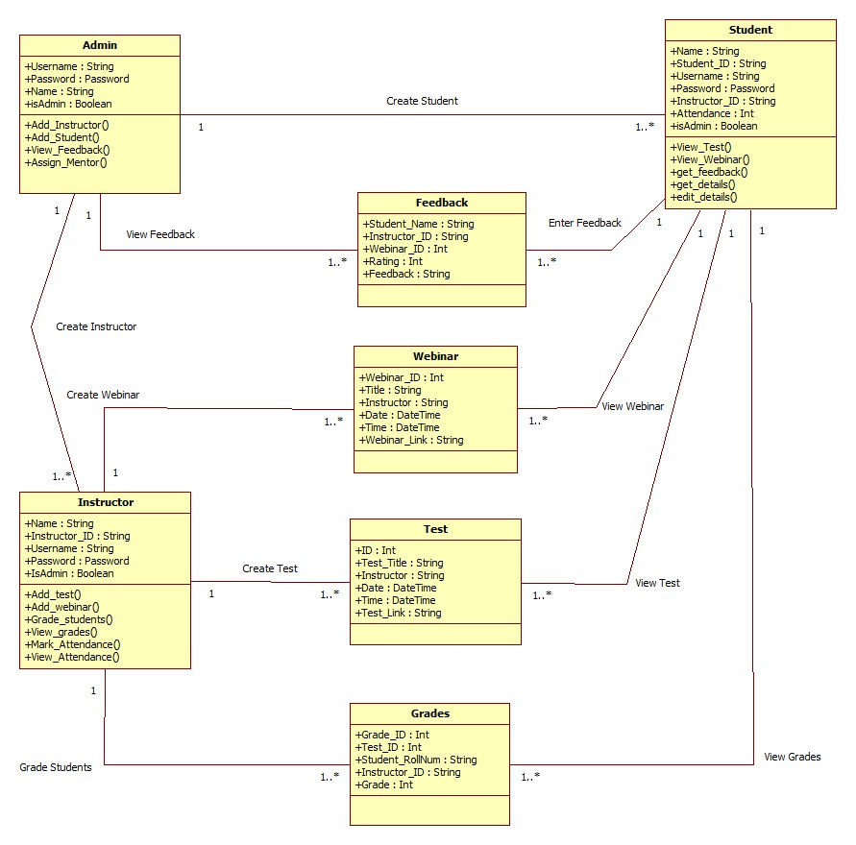

**ACTIVITY DIAGRAM:**

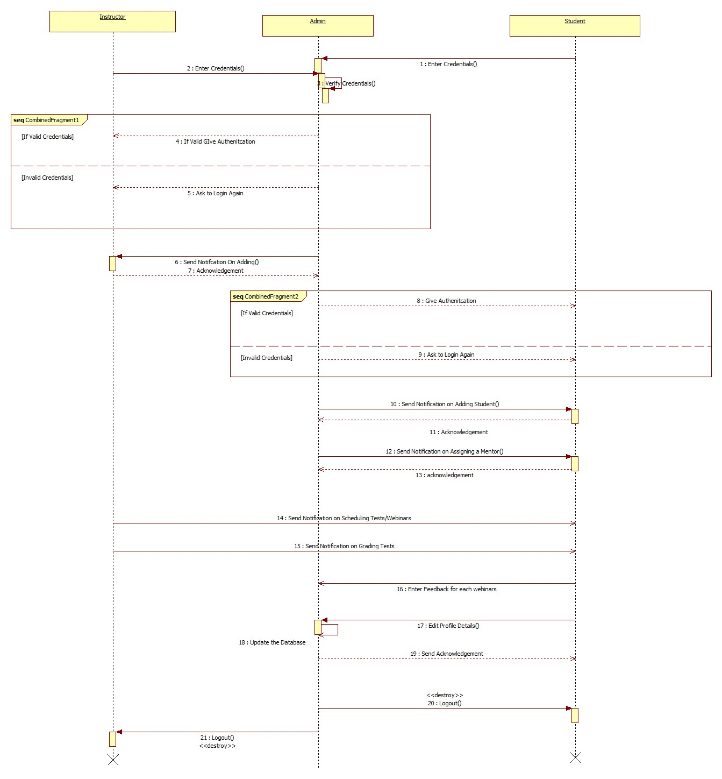

**SEQUENCE DIAGRAM:**

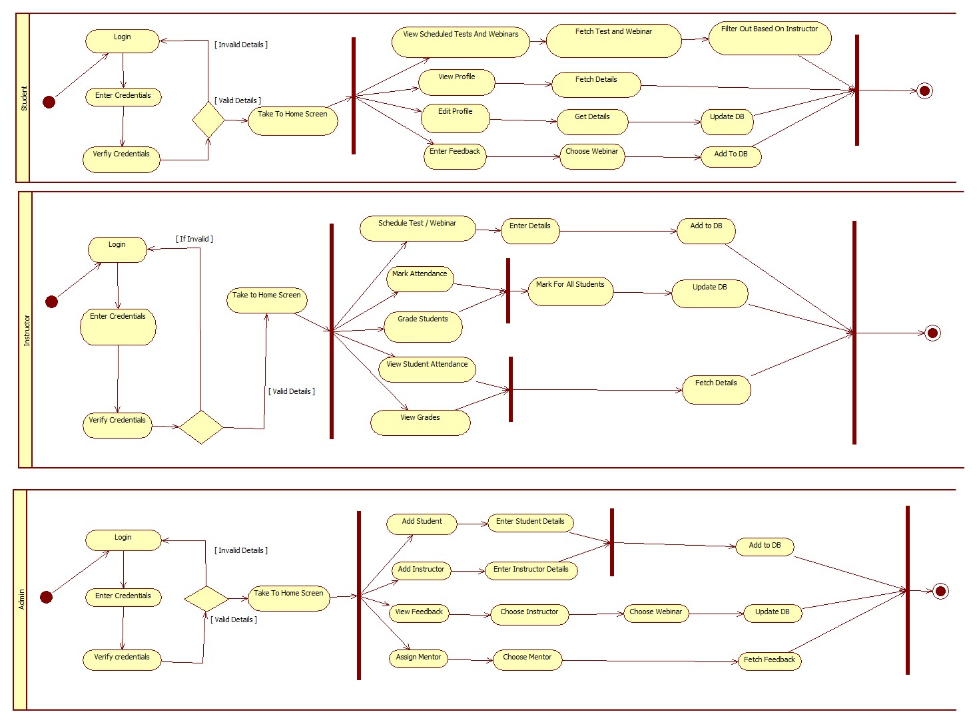

**5. Other Nonfunctional Requirements**

**5.1 Performance Requirements**

For better performance of this software, installation of the newer version of the web browser is required and a basic specification of computer is enough.

**5.2 Safety Requirements**

This software has user credentials for login purposes which have to be encrypted and the files shared between the users should be encrypted.

**5.3 Security Requirements**

This software has to share the assignment and exam files from students to mentors or teachers so it has to be encrypted.

**5.4 Software Quality Attributes**

**Languages Used :**

1. HTML ,CSS
   1. These languages are used for designing the front view of the application
2. JS
   1. This is used as backend language to manage all server side functionalities like routing , rendering templates , passing messages etc
   2. It is also used in frontend for the interactive aspect of the website

Tools and Technologies :

1. Node
   1. This runtime platform is used to serve the JS files so that it is possible to execute JS files outside browser
   2. It executes JS code in asynchronous manner
2. MongoDB
   1. It is used as DataBase to store all details and information related to the application
3. Express
   1. This package is made use to design server fast and efficient
4. Bootstrap
   1. This CSS framework is used to style HTML documents

**5.5 Business Rules**

The admin can control all the faculty and mentors.

The faculty/mentor can monitor all students and assign work or schedule meetings.

The student can view assignments, upload documents, use this platform as a medium of communication between faculty and students.